Procedures to file a request to the Moroccan Office of Industrial and Commercial Property (OMPIC)
for Patent Prosecution Highway Pilot Program
between the OMPIC and the Japan Patent Office (JPO)

Applicants can request accelerated examination by a prescribed procedure including submission of relevant documents on an application which is filed with the OMPIC and satisfies the following requirements under the OMPIC-JPO Patent Prosecution Highway (PPH) pilot program based on the JPO application.

When filing a request for the PPH pilot program, an applicant must submit, to the OMPIC, the request form PPH-JPO (see Annex 2) available on OMPIC’s website at : http://www.ompic.org.ma/fr/content/formulaires-brevets-invention .

The offices may terminate the PPH pilot program if the volume of participation exceeds manageable level, or for any other reason. Ex Ante notice will be published if the PPH pilot program is terminated.

The PPH pilot program will be in effect for three years commencing on April 1, 2021 and will end on March 31, 2024. However, the program may be extended after a joint OMPIC-JPO review and assessment of the program implementation.
PPH using the national work products from the JPO

1. Requirements
- Both the OMPIC application on which PPH is requested and the JPO application(s) forming the basis of the PPH request shall have the same earliest date (whether this be a priority date or a filing date).
For example, the OMPIC application (including PCT national phase application) may be either:
  - an application which validly claims priority under the Paris Convention from the JPO application(s) (examples are provided in ANNEX 1, Figures A, B, C, H, I and J), or
  - an application which provides the basis of a valid priority claim under the Paris Convention for the JPO application(s) (including PCT national phase application(s)) (examples are provided in ANNEX 1, Figures D and E), or
  - an application which shares a common priority document with the JPO application(s) (including PCT national phase application(s)) (examples are provided in ANNEX 1, Figures F, G, L, M and N), or
  - a PCT national phase application where both the OMPIC application and the JPO application(s) are derived from a common PCT international application having no priority claim (an example is provided in ANNEX 1, Figure K).
The OMPIC application, which validly claims priority to multiple JPO or direct PCT applications, or which is the divisional application validly based on the originally filed application that is included in (i) to (iv) above, is also eligible.
The pilot program is not applicable on the basis of JPO ‘utility model’ applications.

(b) At least one corresponding application exists in the JPO and has one or more claims that are determined to be patentable/allowable by the JPO.
The corresponding application(s) can be the application which forms the basis of the priority claim, an application which derived from the JPO application which forms the basis of the priority claim (e.g., a divisional application of the JPO application or an application which claims domestic priority to the JPO application (see Figure C in ANNEX 1), or an JPO national phase application of a PCT application (see Figures J, K, L, M and N in ANNEX 1).
Claims are “determined to be allowable/patentable” when the JPO examiner clearly identified the claims to be allowable/patentable in the latest office action, even if the application is not granted for patent yet.
The office action includes one of the following:
(a) Decision to Grant a Patent
(b) Notification of Reasons for Refusal
(c) Decision of Refusal
(d) Appeal Decision
For example, if the following routine expression is described in the “Notification of Reason for Refusal” of the JPO, those claims are clearly identified to be allowable/patentable.
“<Claims which has been found no reason for refusal>
At present for invention concerning Claim__, no reason for refusal is found.”

(c) All claims on file, as originally filed or as amended, for examination under the PPH must sufficiently correspond to one or more of those claims indicated as allowable in the JPO.
Claims are considered to “sufficiently correspond” where, accounting for differences due to translations and claim format, the claims in the OMPIC are of the same or similar scope as the claims in the JPO, or the claims in the OMPIC are narrower in scope than the claims in the JPO.
In this regard, a claim that is narrower in scope occurs when a JPO claim is amended to be further limited by an additional feature that is supported in the specification (description and/or claims).
A claim in the OMPIC which introduces a new/different category of claims to those claims indicated as allowable in the JPO is not considered to sufficiently correspond. For example, where the JPO claims only contain claims to a process of manufacturing a product, then the claims in the OMPIC are not considered to sufficiently correspond if the OMPIC claims introduce product claims that are dependent on the corresponding process claims.
If the PPH request is granted, any claims amended or added after an office action need not to sufficiently correspond to the claims indicated as patentable in the JPO application.

(d) The OMPIC has not begun examination of the application at the time of request for the PPH (an example is provided in ANNEX 1, figure O).

2. Documents to be submitted
Documents (a) to (d) below must be submitted by attaching to the PPH request.

- Copies of all office actions (which are relevant to substantial examination for patentability in the JPO) which were issued for the corresponding application by the JPO, and translations of them.
Either Arabic, French or English is acceptable as translation language. The applicant does not have to submit a copy of JPO office actions and translations of them when those documents are provided via JPO’s dossier access system because the office actions and their machine translations are available for the OMPIC examiner via the JPO’s dossier access system. If they cannot be obtained by the OMPIC examiner via the JPO’s dossier access system, the applicant may be notified and requested to provide the necessary documents.

- Copies of all claims determined to be patentable/allowable by the JPO, and translations of them.
Either Arabic, French or English is acceptable as translation language. The applicant does not have to submit a copy of claims indicated to be allowable/patentable in the JPO, and translations thereof when the documents are provided via JPO’s dossier access system because they are available for the OMPIC examiner via the JPO’s dossier access system.

Regarding (a) and (b), if the OMPIC examiner cannot obtain the copy of office actions or claims, indicated to be allowable/patentable in the JPO, and translations thereof via the JPO’s dossier access system, or if it is impossible for him to understand the office actions or the claims due to insufficient translation, the examiner can request the applicant to resubmit the copy of the office actions or claims and translations thereof.

- Copies of references cited by the JPO examiner
If the references are patent documents, the applicant doesn’t have to submit them because the OMPIC usually possesses them. When the OMPIC does not possess the patent document, the applicant has to submit the patent document at the examiner’s request. Non-patent literature must always be submitted with, if necessary, a translation into Arabic, French or English.
The translations of the patent references are unnecessary.

- Claim correspondence table
The applicant requesting PPH must submit a claim correspondence table, which indicates how all claims in the OMPIC application sufficiently correspond to the patentable/allowable claims in the JPO application.
When claims are just literal translation, the applicant can just write down that “they are the same” in the table. When claims are not just literal translation, it is necessary to explain the sufficient correspondence of each claim.

When the applicant has already submitted above documents (a) to (d) to the OMPIC through simultaneous or past procedures, the applicant may incorporate the documents by reference and does not have to attach them.

3. Procedure for accelerated examination under the PPH Pilot Program before the OMPIC
The applicant fills out the form PPH-JPO (see Annex 2) requesting accelerated examination under the PPH Pilot Program between JPO and OMPIC (the form PPH-JPO) available on the OMPIC website and submit all the relevant supporting documents mentioned above.

The request for accelerated examination is considered by the patent examiner in charge of the corresponding patent application.

If all the requirements referred to in point 1. above are met, and the relevant documents referred to in point 2. above are submitted, the examiner proceeds to an accelerated examination of the application.

If the examiner considers that one of the requirements is not met, and in the case of the failure by the applicant to comply with the said requirements within a time limit, the examiner informs the applicant that he is not allowed to benefit from the accelerated procedure according to the PPH and explains the reasons for this.Furthermore, the applicant may at any time, as long as OMPIC has not started the examination of the patent application, re-file a new request for accelerated examination under the PPH.

Annex 1

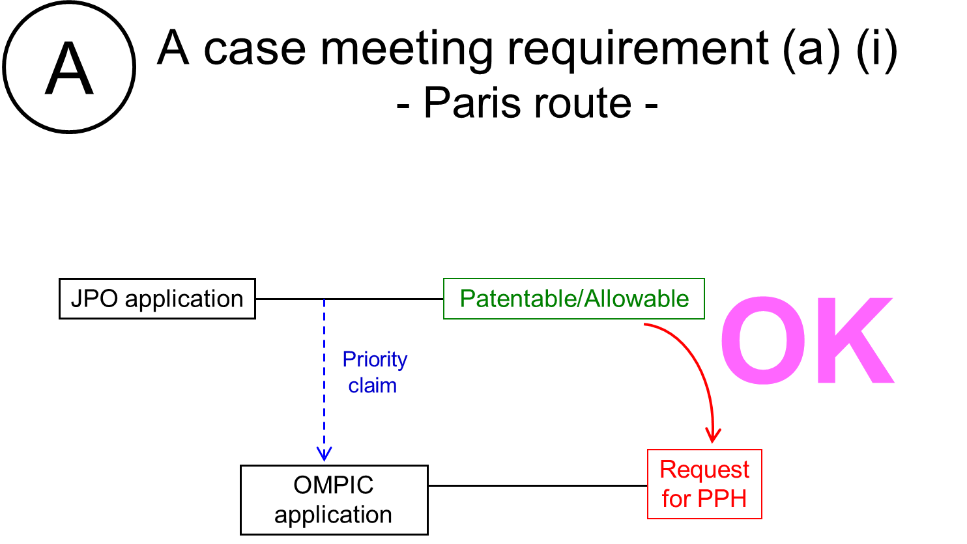

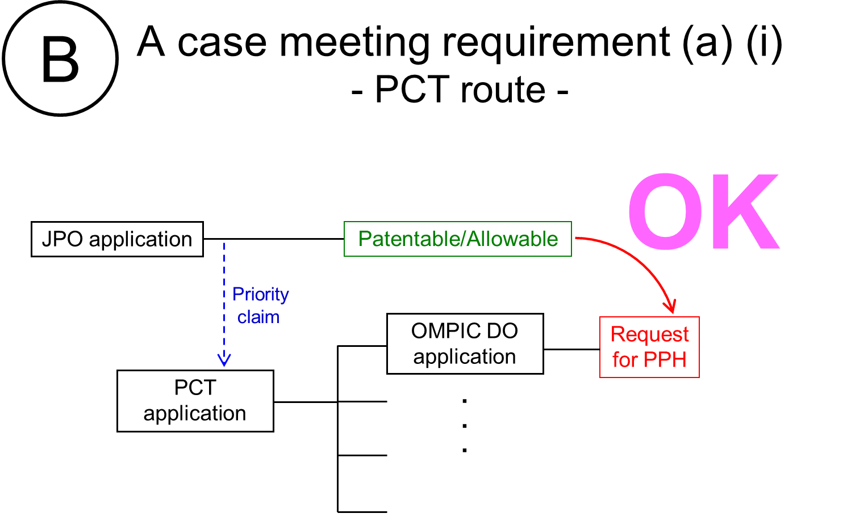

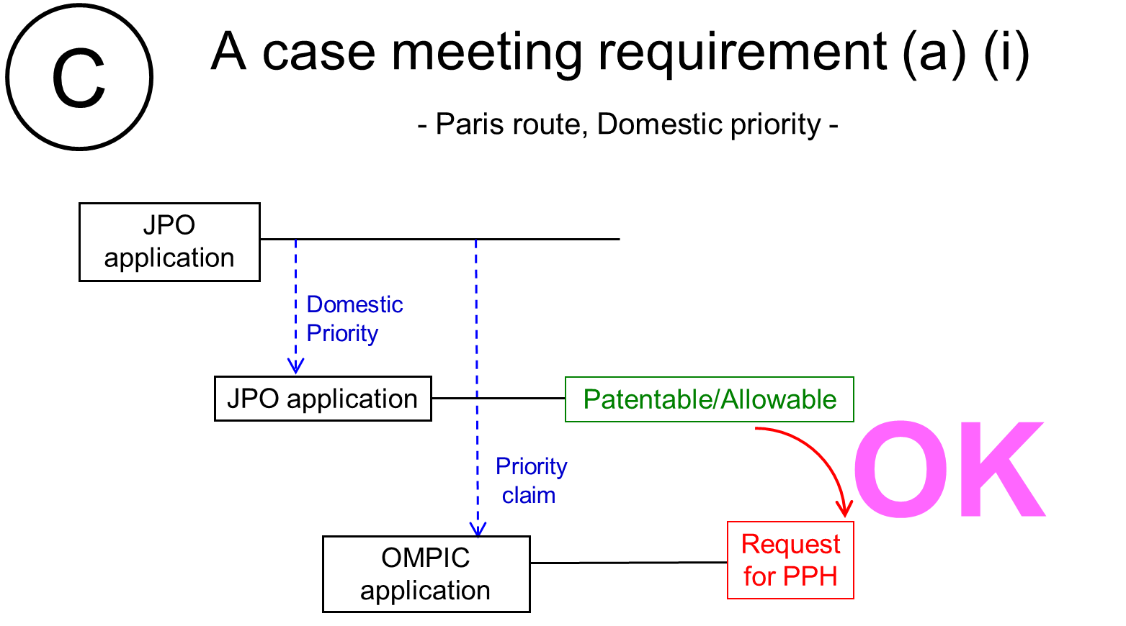

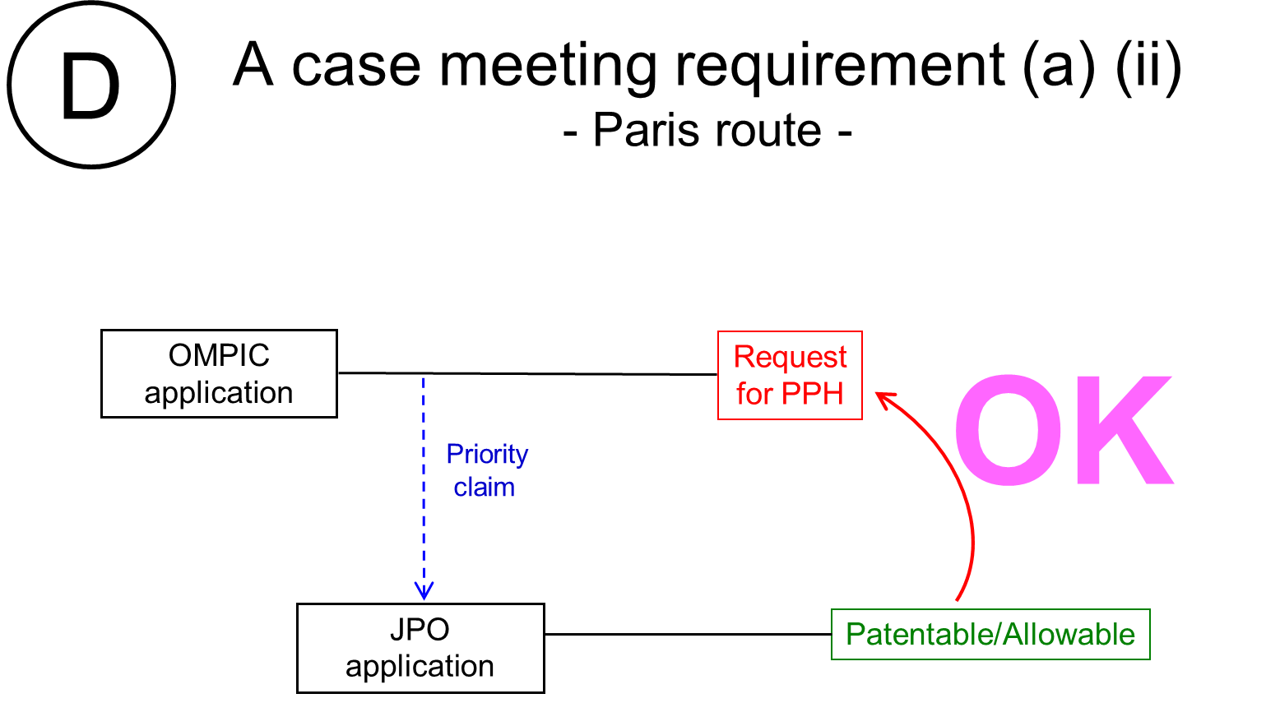
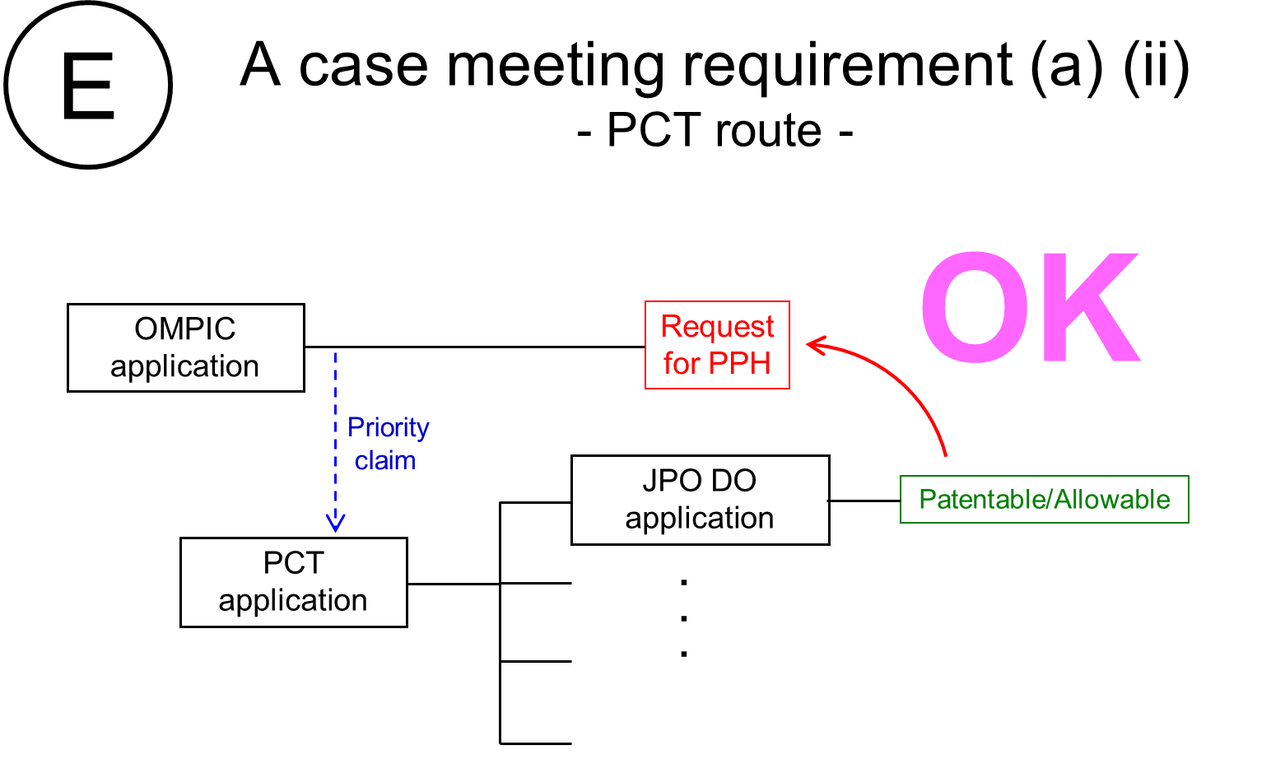

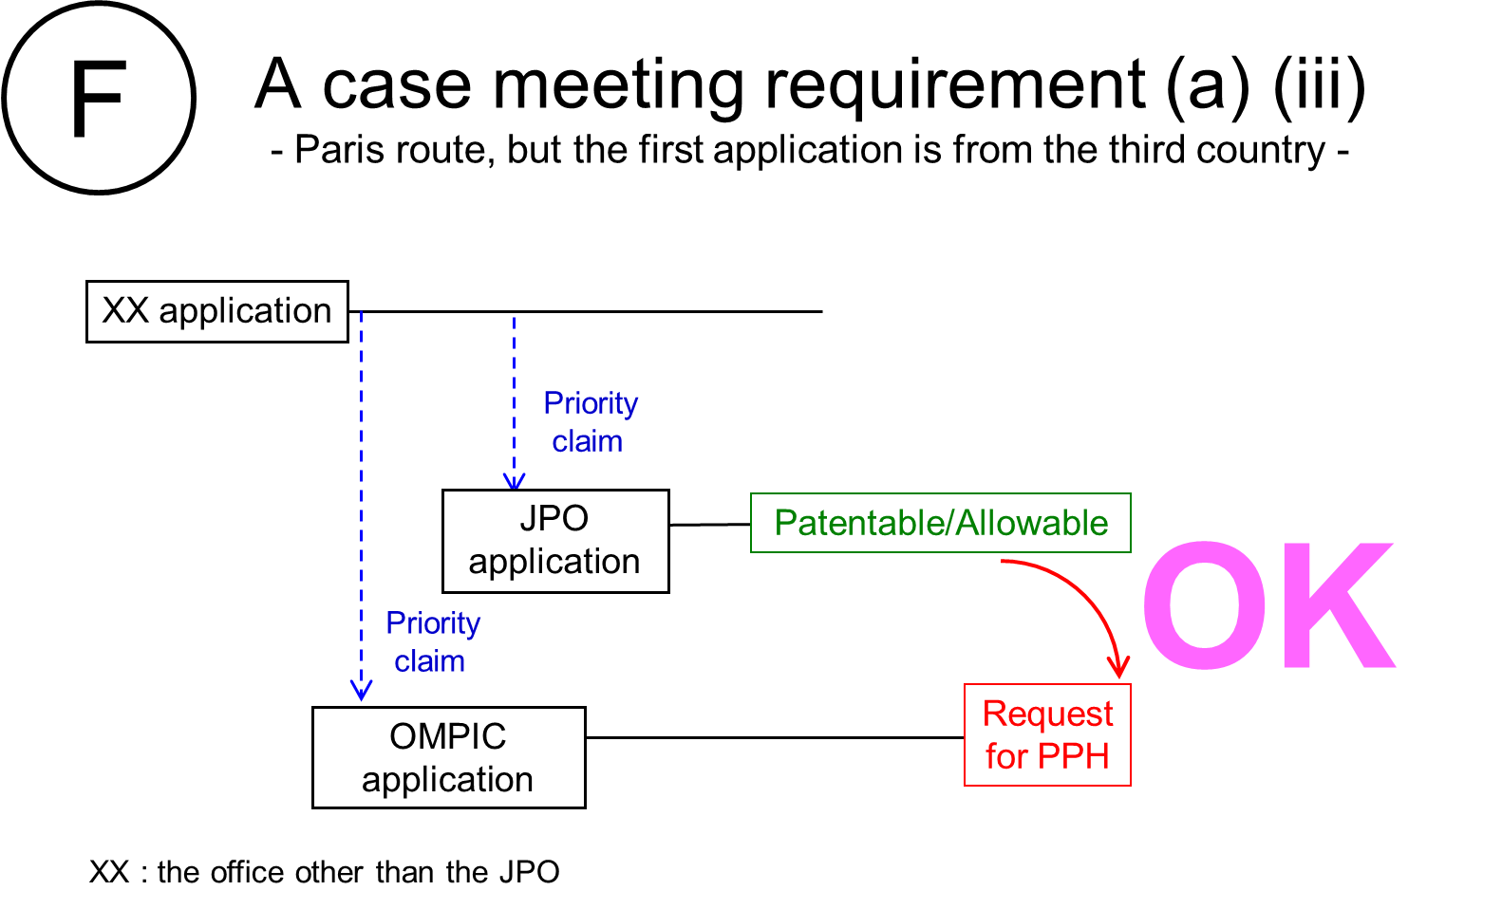

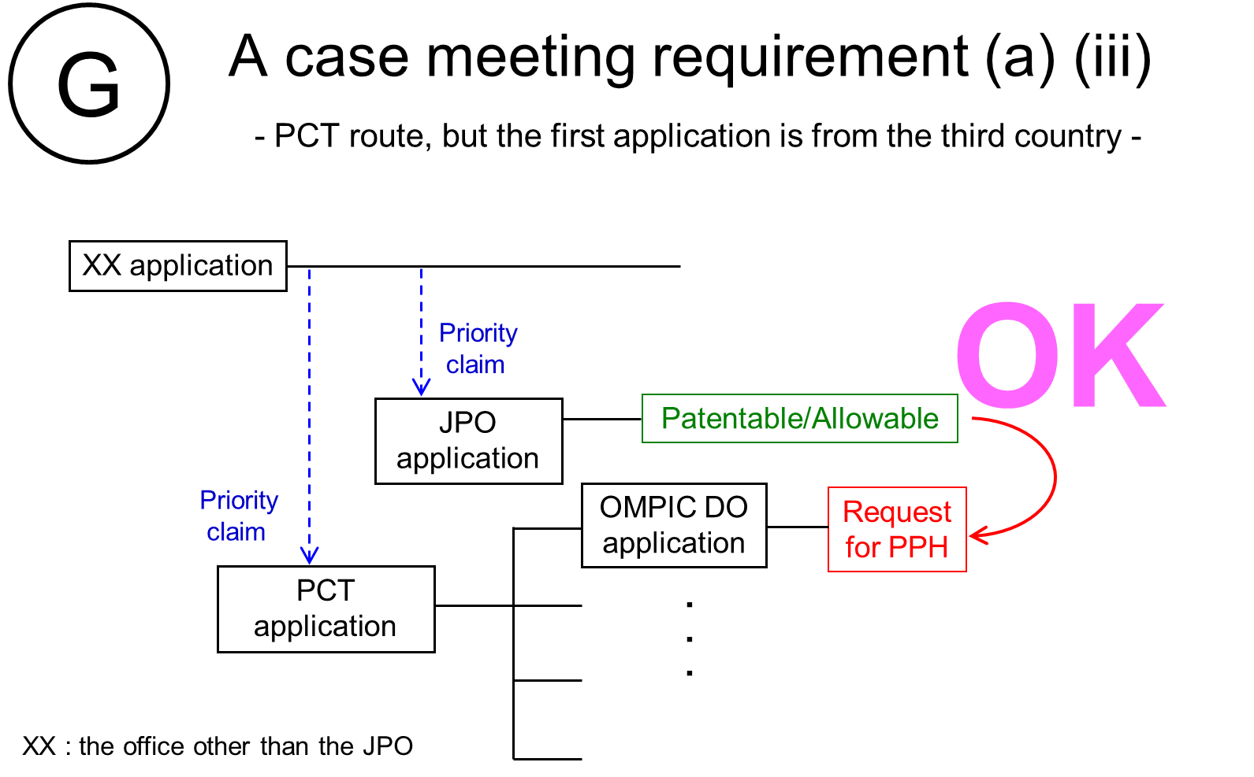

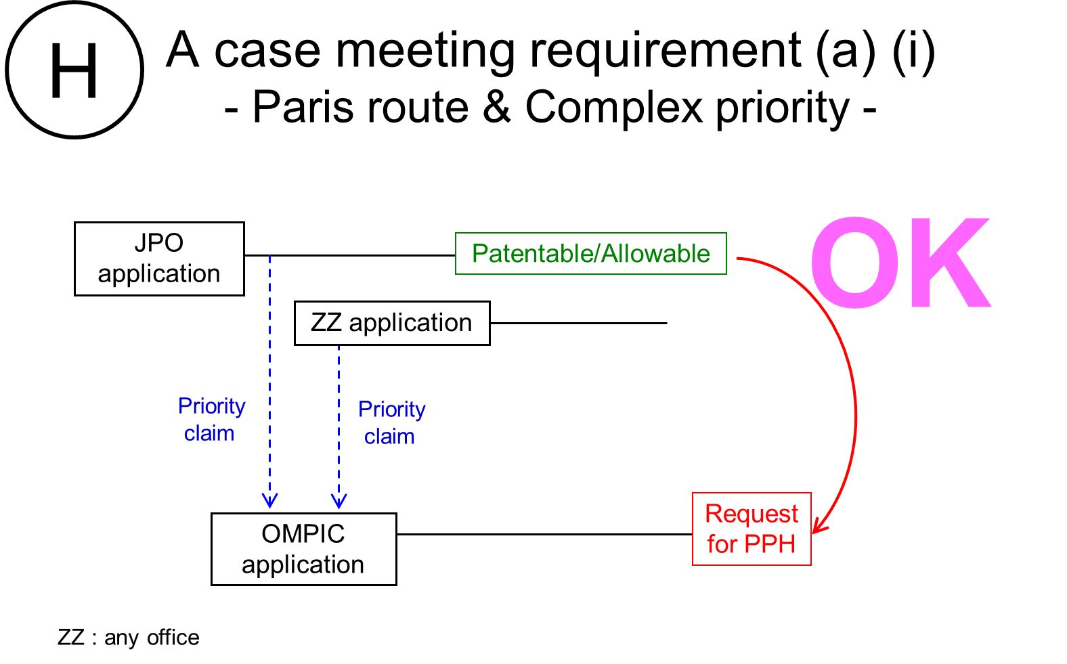

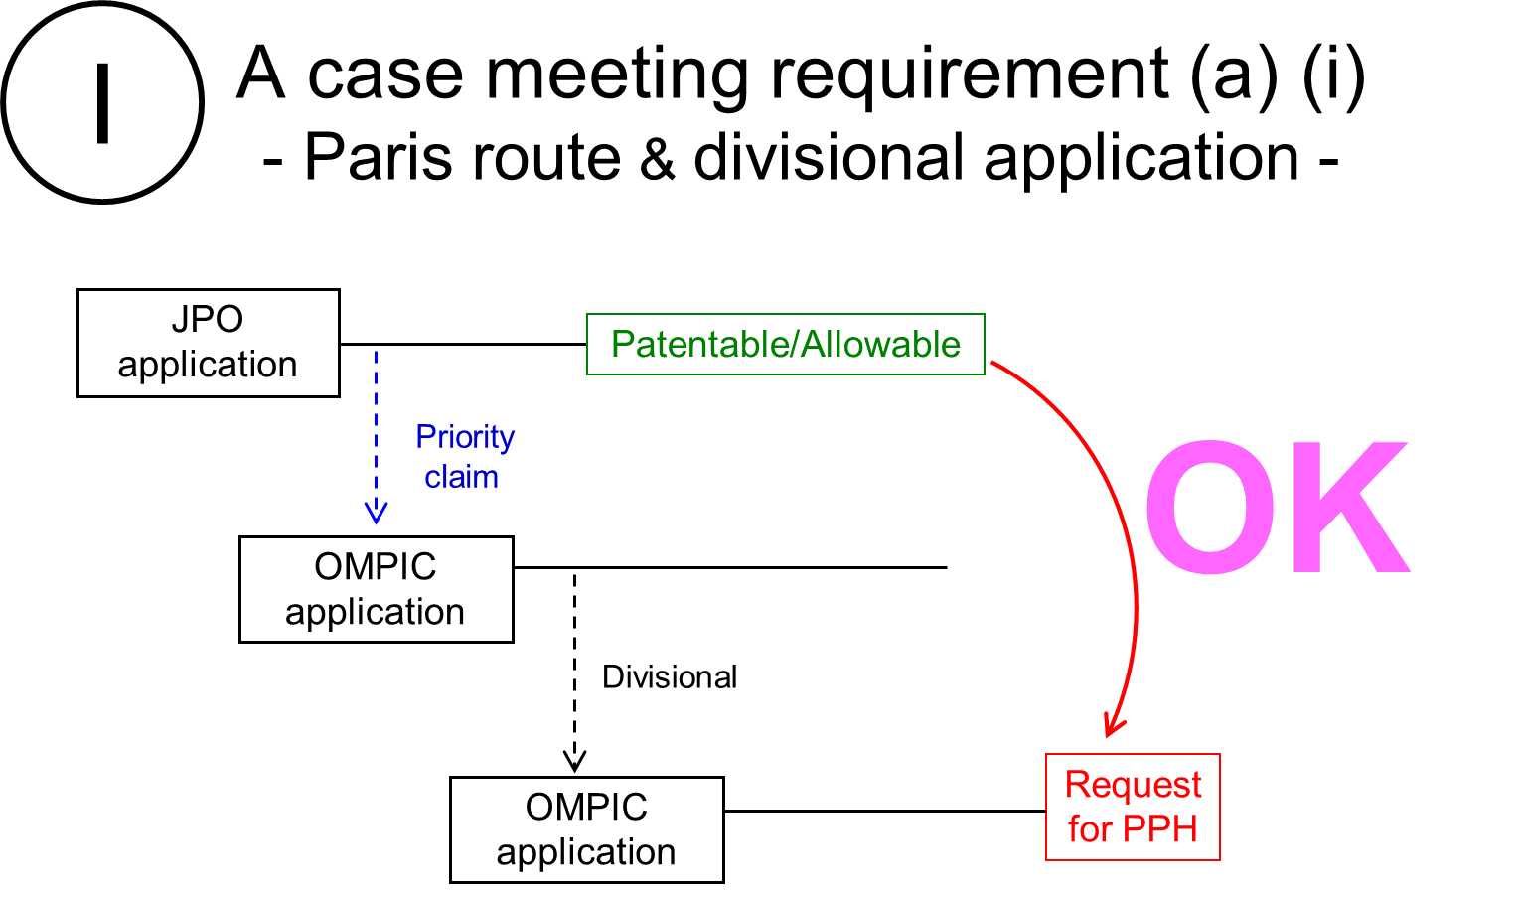

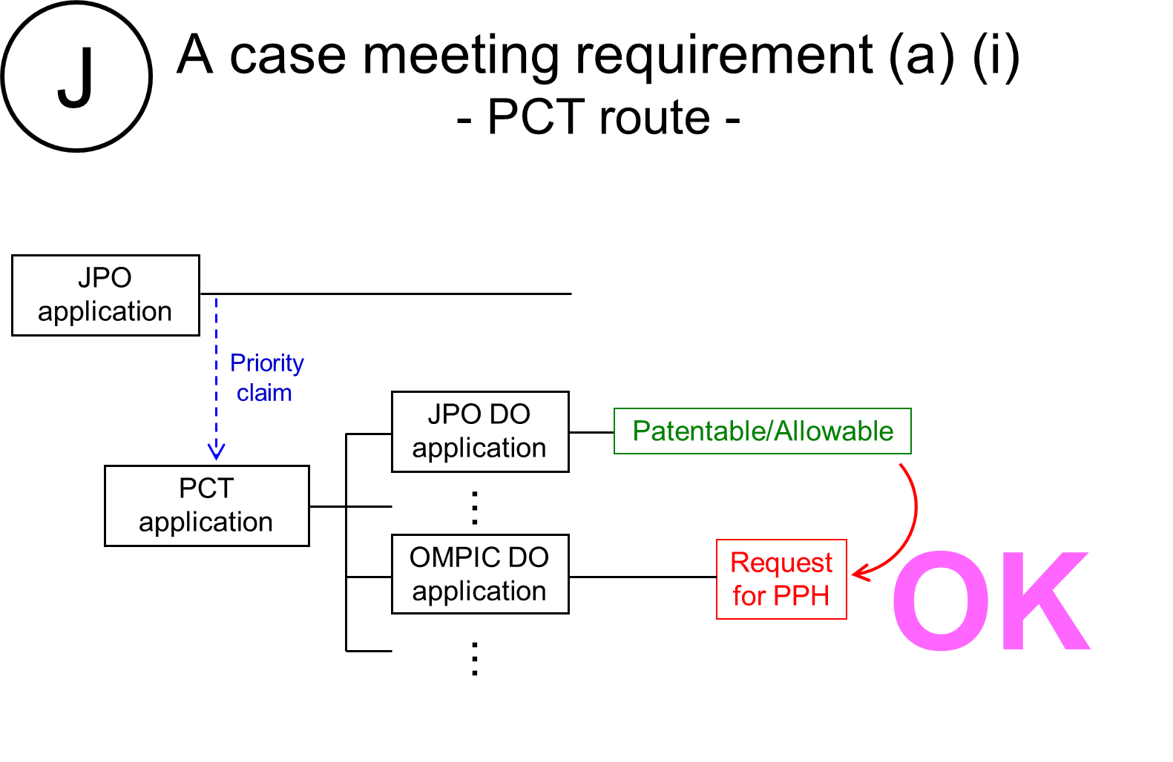

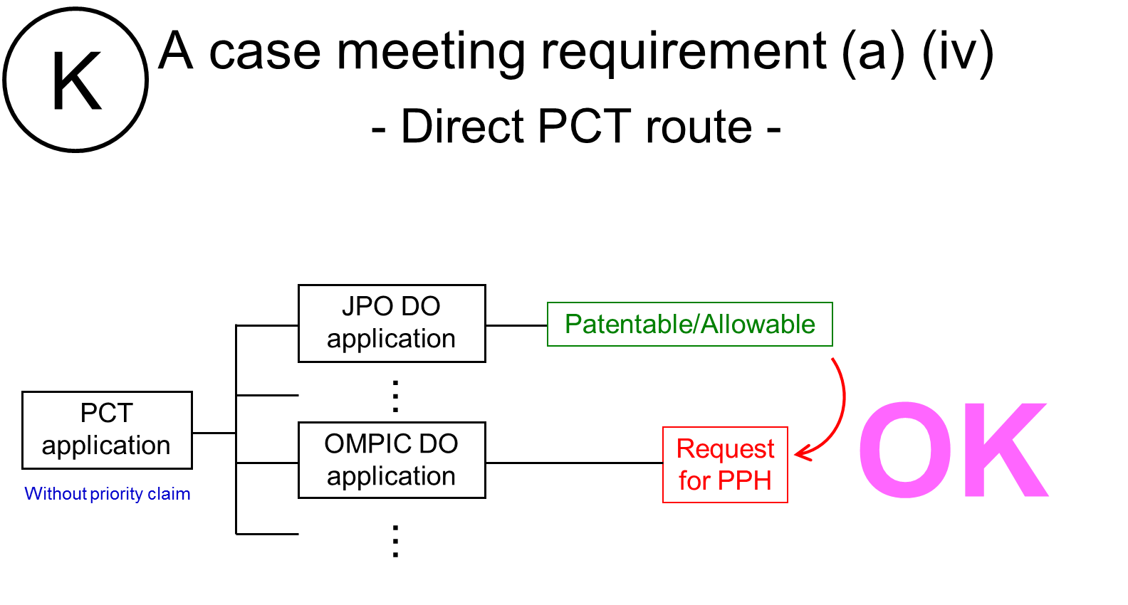

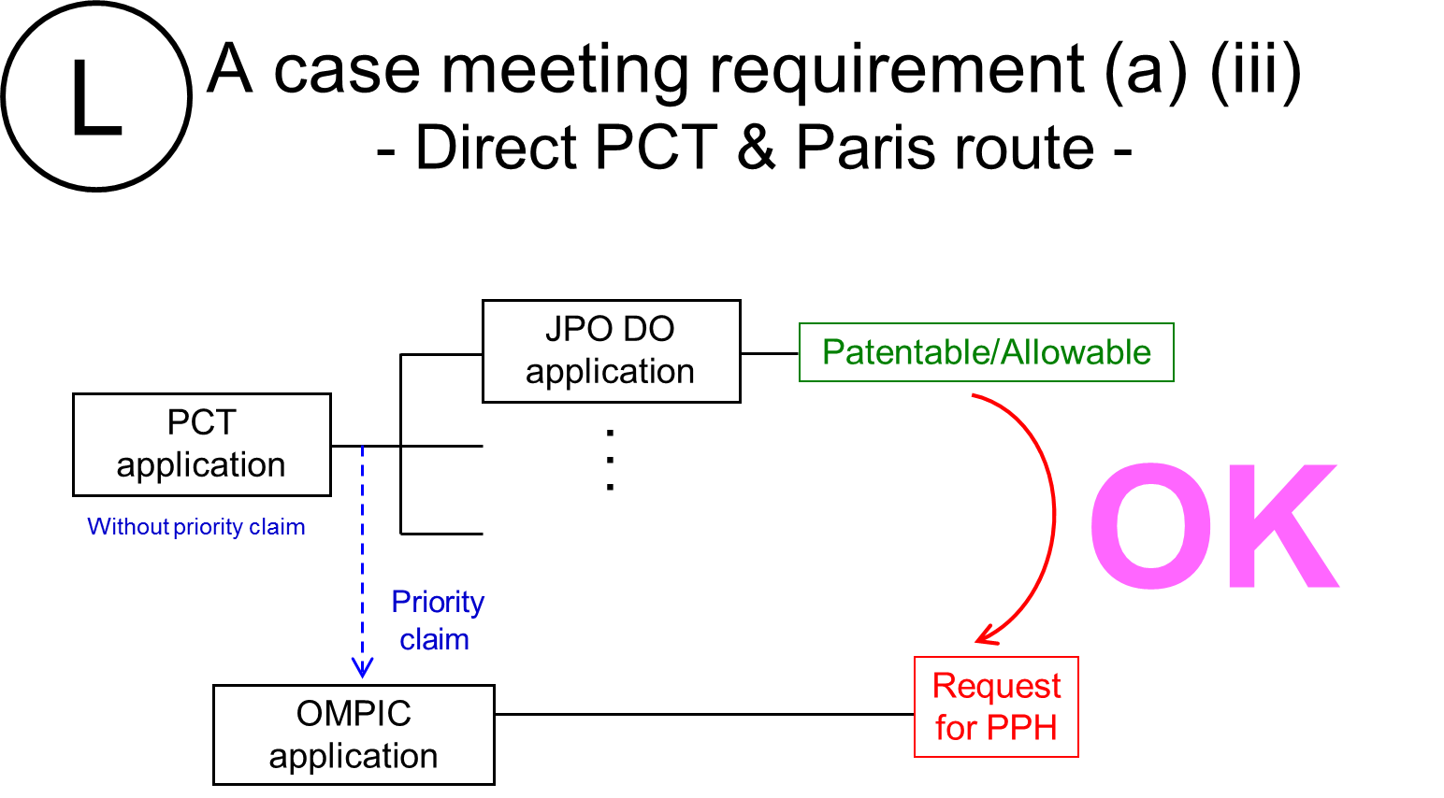

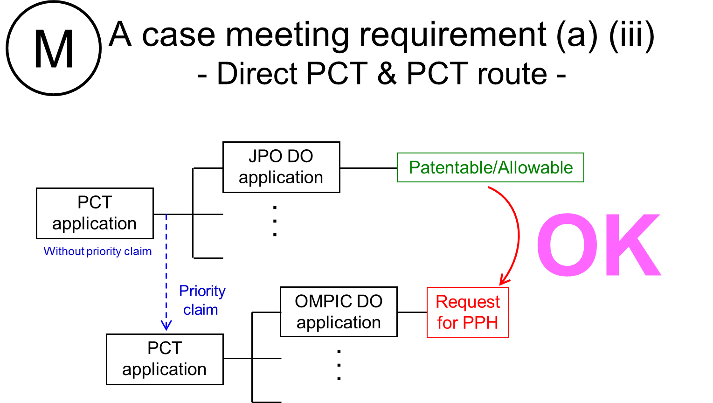

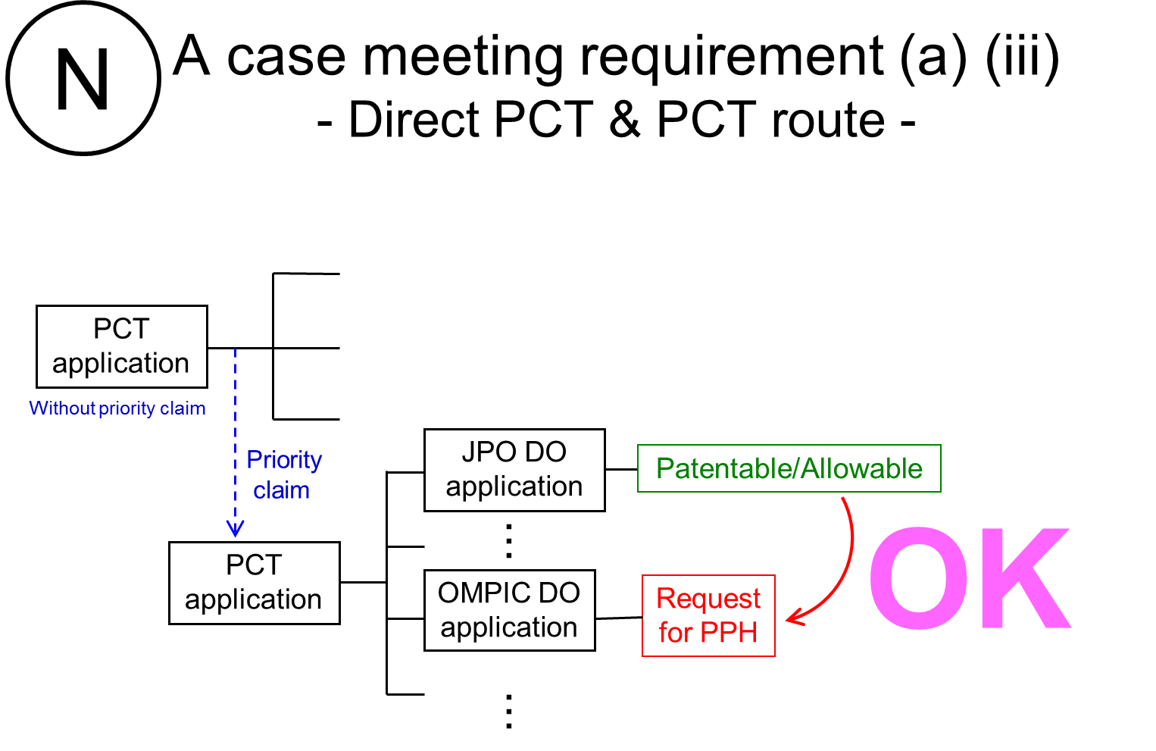

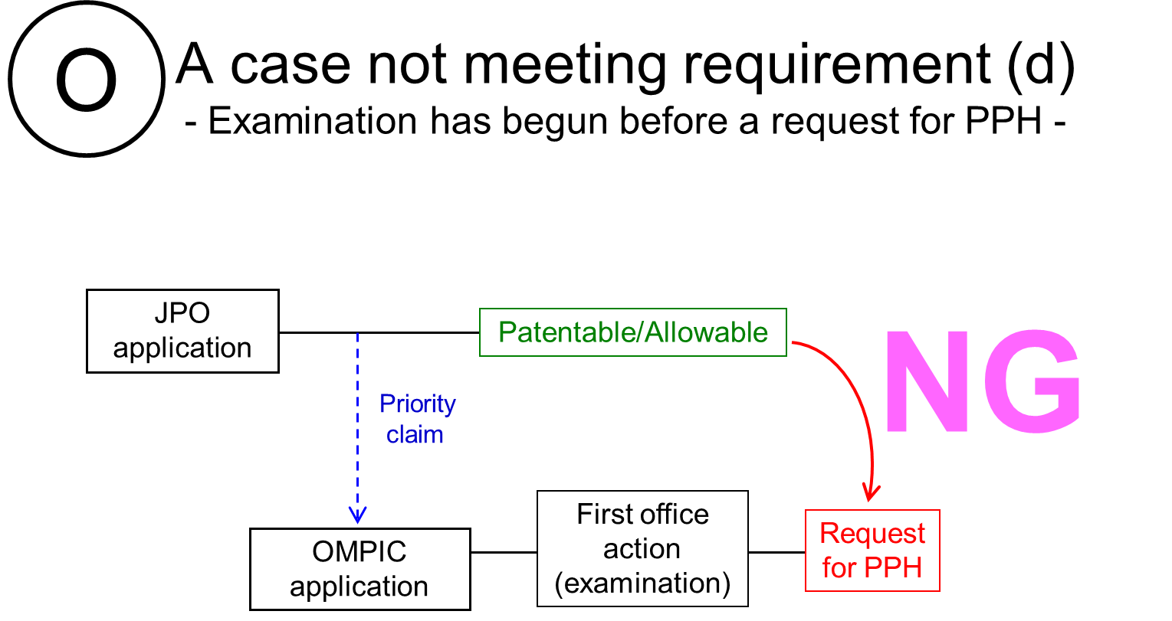

Annex 2
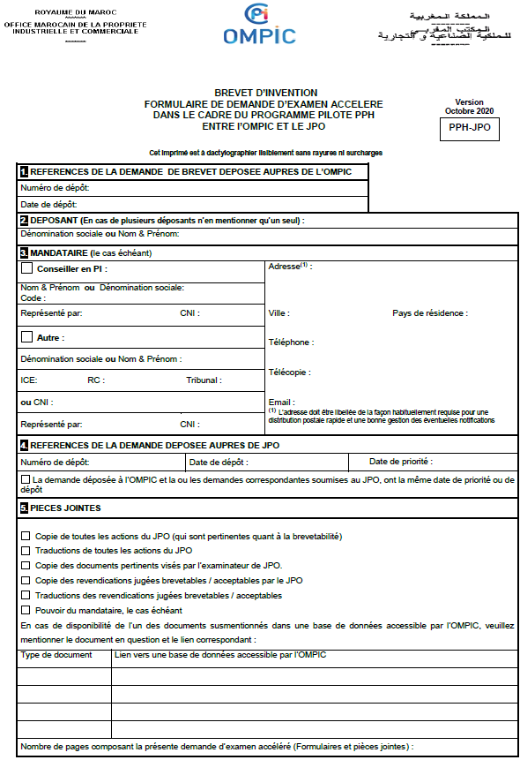
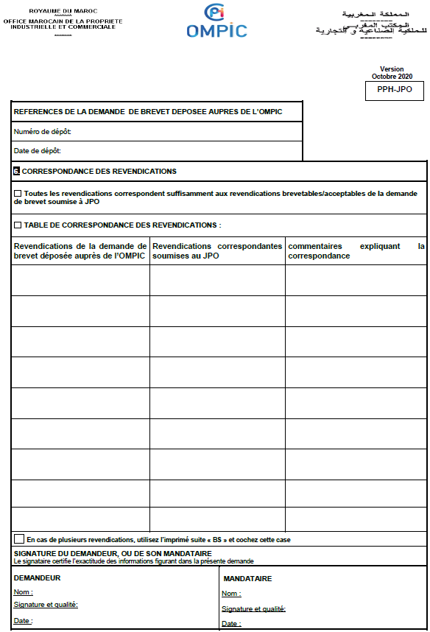
Annex 2 (reference translation in Japanese)
